

School: ............................................................................................................. Campus: ....................................................... Academic Year: ...................... Subject Name: ........................................................... Subject Code: ..........................

Semester: ............... Program: ........................................ Branch: ......................... Specialization: .......................... Date: .....................................

(Learning by Doing and Discovery)

**\* Coding Phase: Pseudo Code / Flow Chart / Algorithm**

Page No…………….

***\* As applicable according to the experiment.***

***Two sheets per experiment (10-20) to be used.***

1. Check MetaMask wallet for sufficient Ethereum Sepolia testnet tokens. If not then drip from Google Faucet.

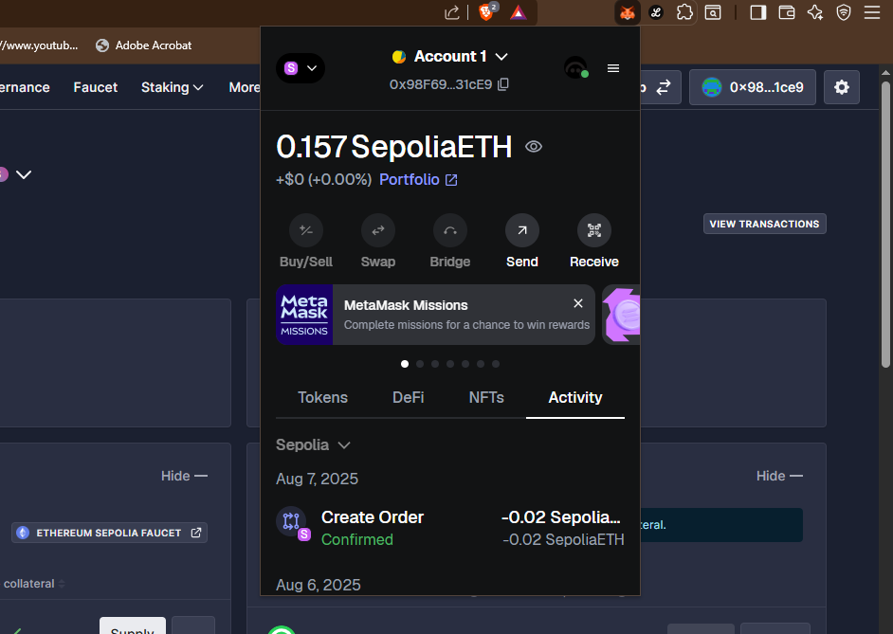

1. Open <https://app.aave.com> in the browser where you have MetaMask wallet.

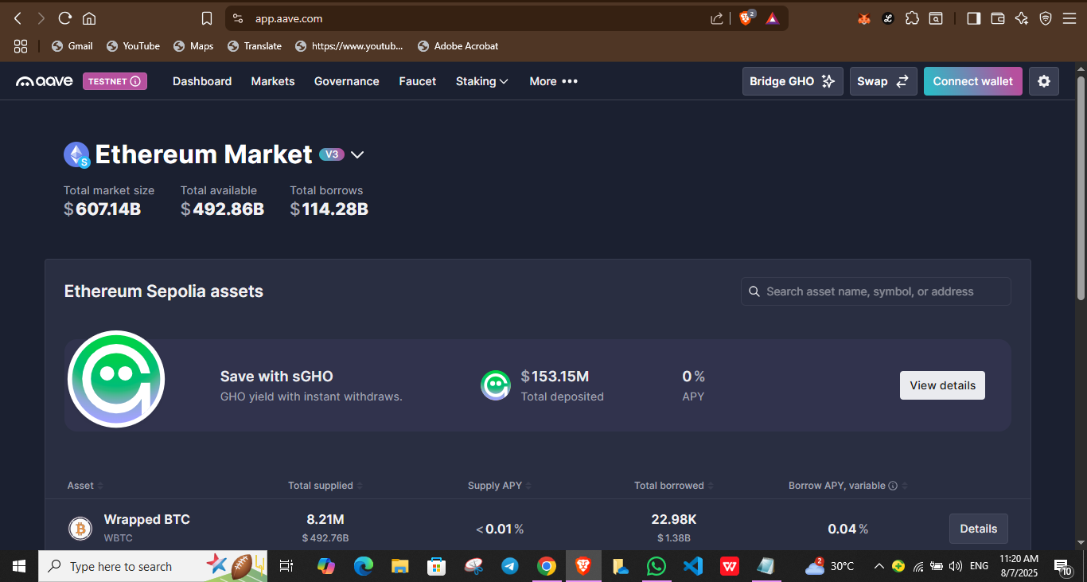

1. Connect MetaMask wallet.

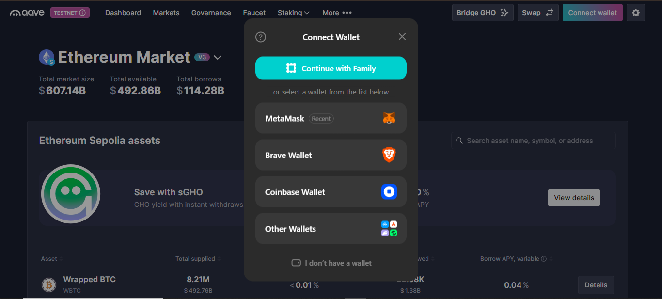

Page No…………….

***\* As applicable according to the experiment.***

***Two sheets per experiment (10-20) to be used.***

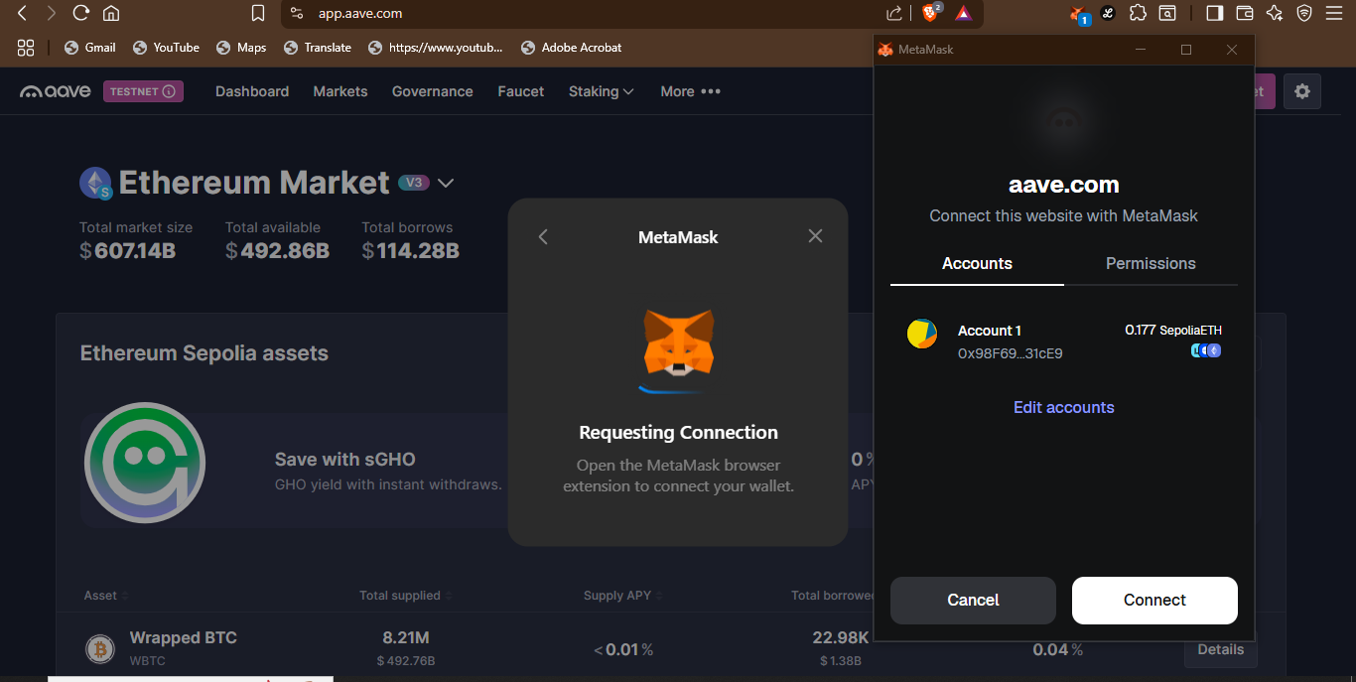

1. Change network to Ethereum Sepolia testnet.

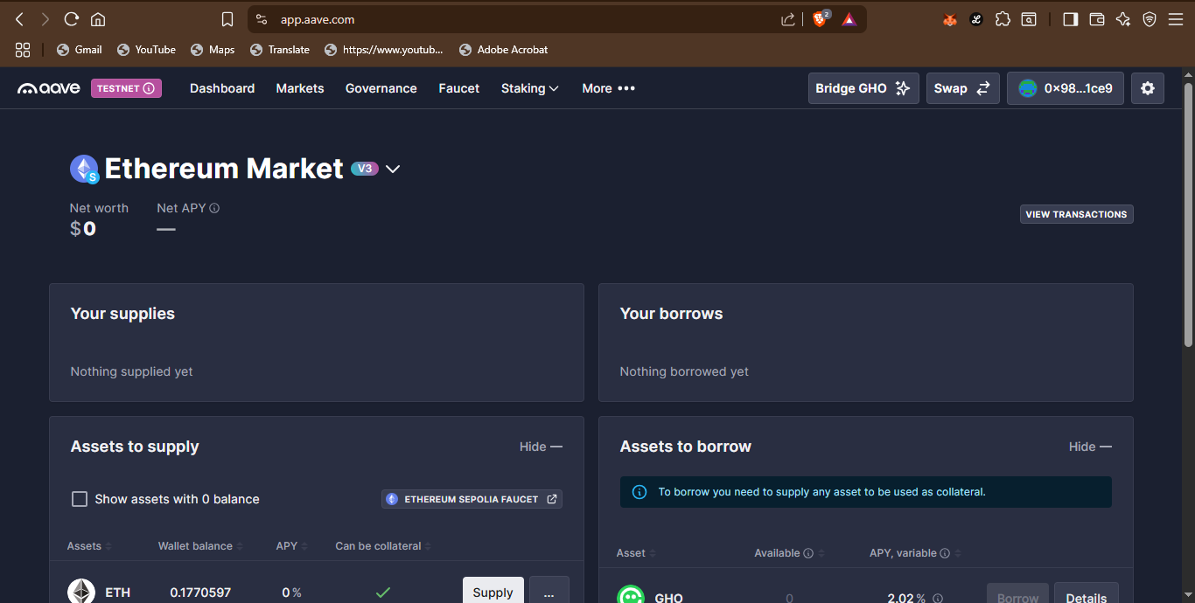

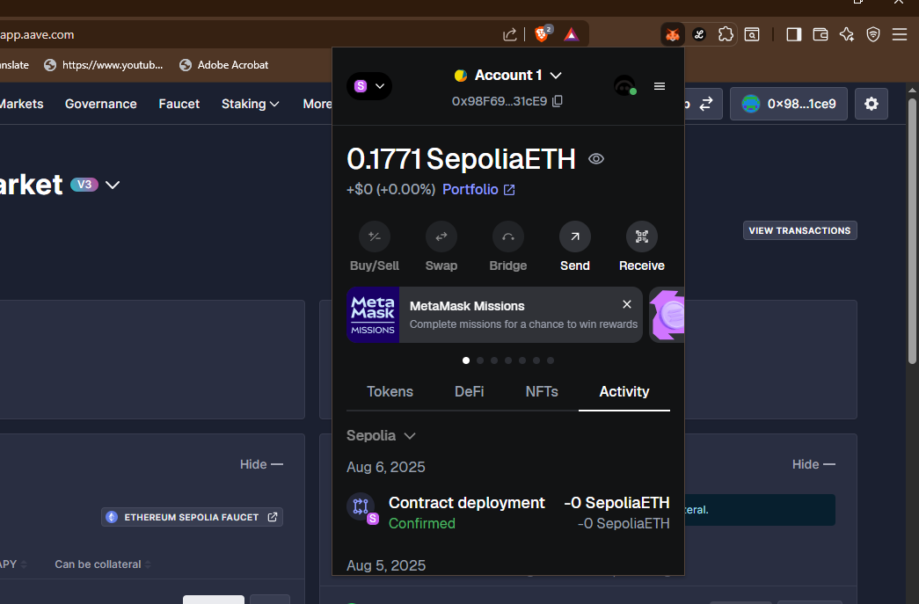

Page No…………….

***\* As applicable according to the experiment.***

***Two sheets per experiment (10-20) to be used.***

1. Then swap the Ethereum Sepolia test tokens to DAI tokens or any tokens of your choice.

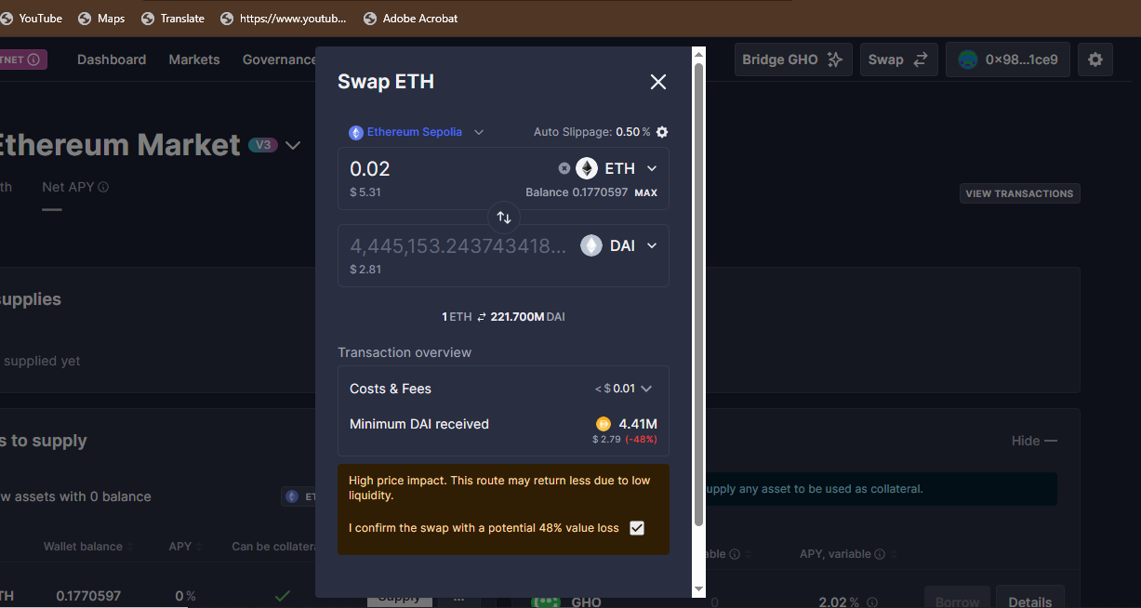

1. Confirm the transaction request on MetaMask wallet.

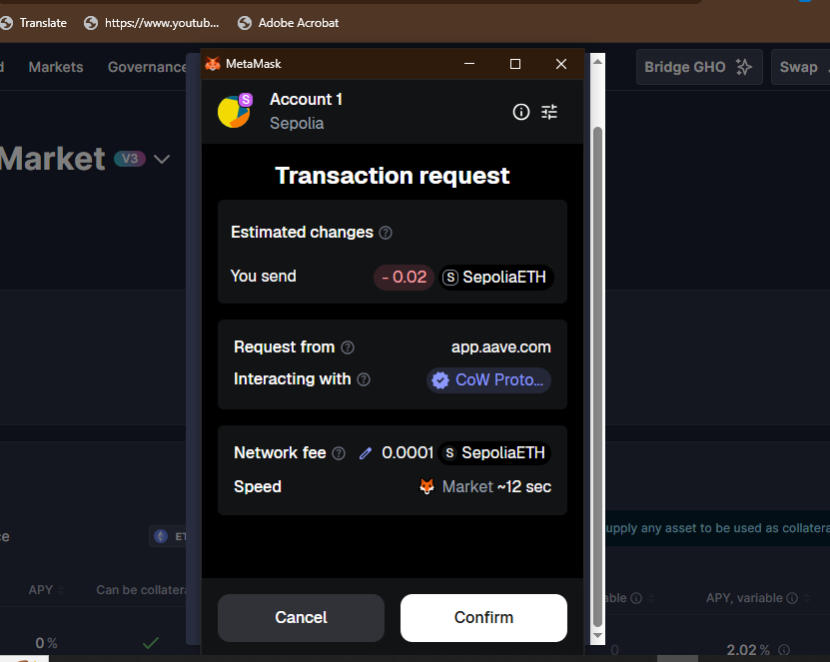

1. It will take some time, then your transaction will be confirmed.

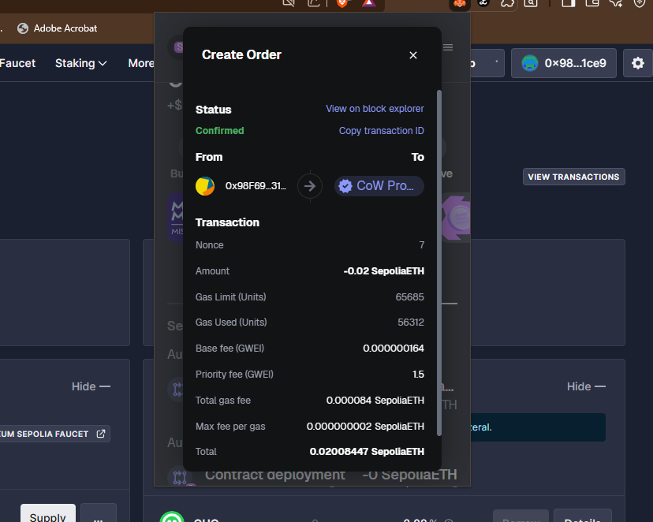

**\*Softwares used**

1. Aave.com
2. MetaMask
3. Brave

**Testing Phase: Compilation of Code (error detection)**

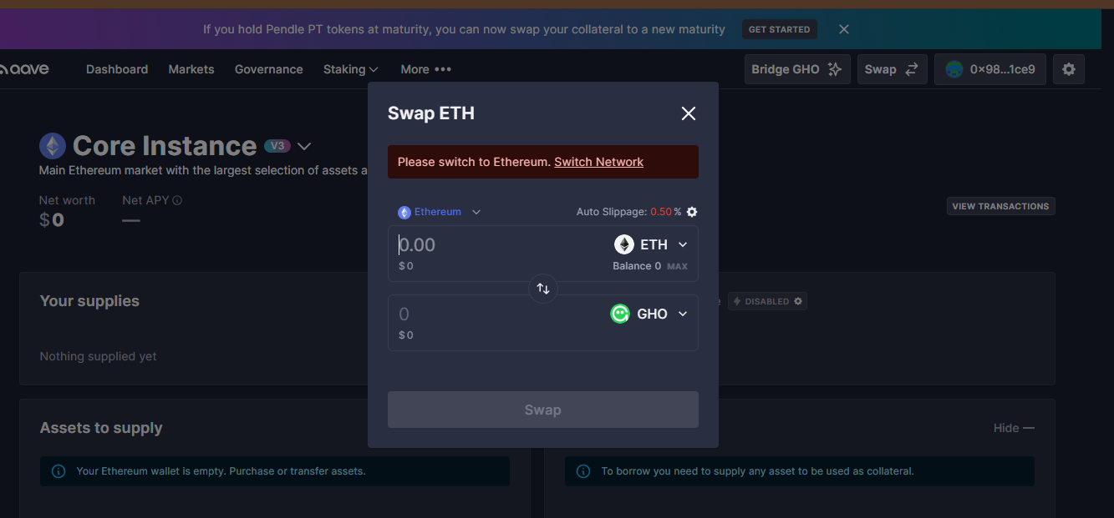

Page No…………….

***\* As applicable according to the experiment.***

***Two sheets per experiment (10-20) to be used.***

**Implementation Phase: Final Output (no error)**

Page No…………….

***\* As applicable according to the experiment.***

***Two sheets per experiment (10-20) to be used.***

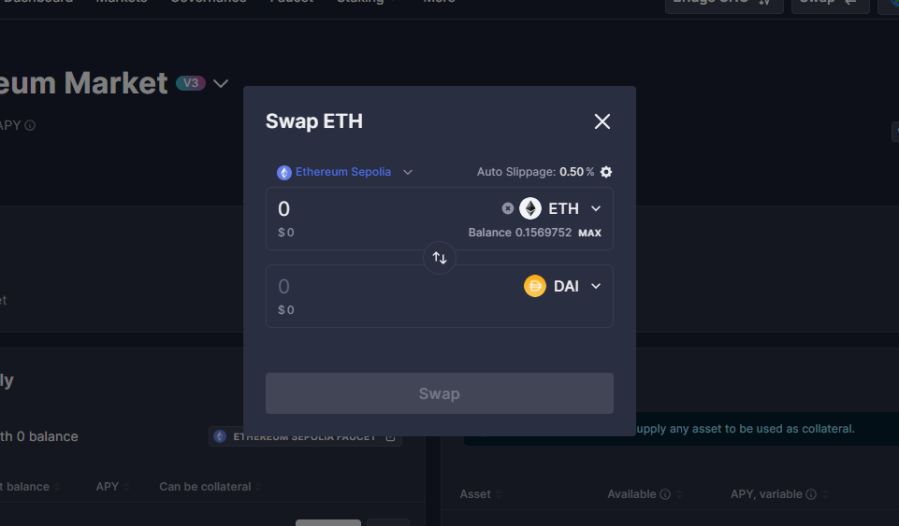

# * Observations

1. I used test tokens to lend and borrow assets on Aave without risking real money.
2. Swapping tokens on Uniswap felt fast and didn’t need any middlemen.
3. MetaMask made it easy to approve and sign each transaction.
4. I saw how gas fees work, even on test networks.
5. All my actions were recorded on the blockchain — fully transparent and trackable.

Page No…………….

***\* As applicable according to the experiment.***

***Two sheets per experiment (10-20) to be used.***

**ASSESSMENT**

|  |  |  |  |
| --- | --- | --- | --- |
| **Rubrics** |  |  |  |
| Concept | 10 |  |  |
| Planning and Execution/  Practical Simulation/ Programming | 10 |  |  |
| Result and Interpretation | 10 |  |  |
| Record of Applied and Action Learning | 10 |  |  |
| Viva | 10 |  |  |
| **Total** | **50** |  |  |